Task 10:
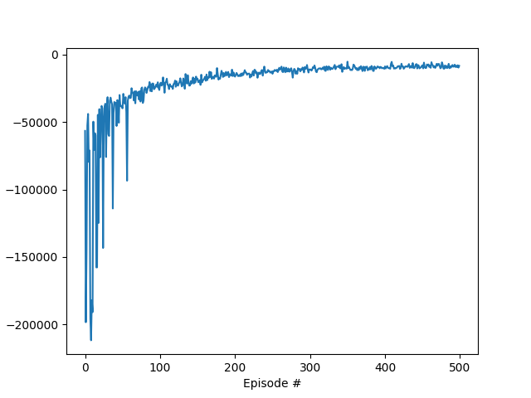
Graph 1 (volume_lane_fast: number of vehicles per lane)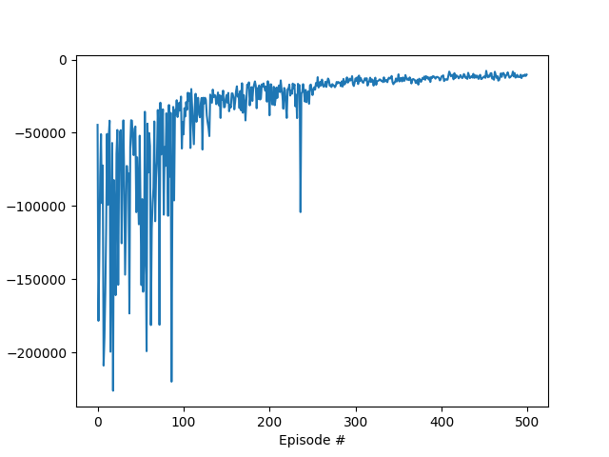
Graph 2 (congestion_length: number of stopped vehicles/congestion length)
Comparison of the Two State Representations:
Graph 1 (volume_lane_fast: Number of vehicles per lane)
- The reward increases relatively quickly and stabilizes after approximately 300 episodes.
- The learning curve appears generally stable and smooth.
- The agent rapidly learns an effective strategy to optimize traffic flow, resulting in efficient traffic control.
Graph 2 (congestion_length: Number of stopping vehicles / congestion length)
- The reward also increases, but exhibits greater fluctuations and is overall less stable.
- The learning speed is somewhat slower compared to the first graph, and the final reward value appears to be lower.
- This representation better reflects the actual congestion state, capturing realistic traffic conditions more accurately.

Qualitative Summary (Task 10):
The state representation based on the number of vehicles per lane (volume_lane_fast) leads to a faster and more stable learning process, achieving a higher cumulative reward. This suggests that the agent is able to quickly identify and implement an efficient traffic signal control strategy.
In contrast, the congestion length representation results in a more volatile learning curve and slower convergence, with lower final rewards. However, it provides a more realistic measurement of traffic congestion by focusing on stopped vehicles rather than just vehicle counts.
Thus, while the volume-based representation improves training efficiency and performance, the congestion-based approach may offer better fidelity to actual traffic states, potentially requiring more training time to reach comparable effectiveness.

